Name________________________________________________ Date______________ Per.____
Test Study Guide
Standard 03: Newton’s 1st Law of Motion
Standard 04: Newton’s 2nd Law of Motion
Standard 05: Newton’s 2nd Law of Motion

- A book is sitting on the dashboard of a car that is stopped at a traffic light. As the car starts to move forward, the book slides backward off the dashboard. Use Newton’s 1st Law to explain what happened.

- Sort the quantities into vectors or scalars and complete the table below.
Vector | Scalar
20 mph south 78°F
10 meters to the right 16 feet
16 Newtons 16 Newtons left

- Below is a graph of a Central Magnet long distance runner. (distance/time graph)
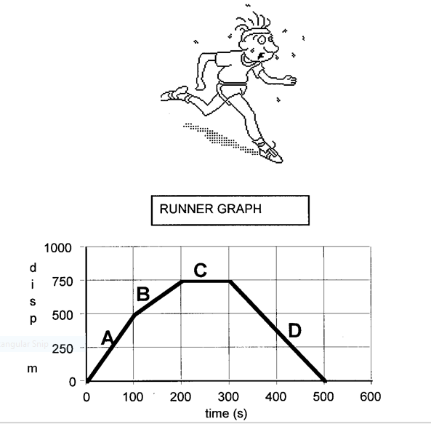
Place the correct letter in the space provided
____ Runner was tired and decided to take a break
____ Running at a fast pace
____ Runner has returned to the start position
____Running at a steady, constant speed

Match the following graphs to the kind of motion they describe.
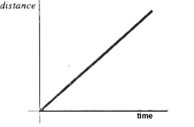 | 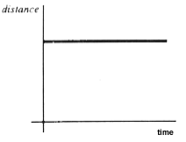 | 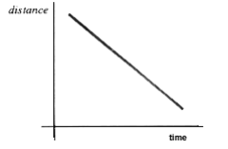
A. B. C.

____Constant positive acceleration
____Constant negative acceleration
____Object at rest

Draw a diagram to show the force applied and calculate the net force.
- Mrs. Elliott and Mr. Elliott decided to move the cabinet in their dining room. Mrs. Elliott stood on one side, and Mr. Elliott stood on the other. They each pushed with 30 N of force. What was the net force on the cabinet? ____________

- Two soccer players kick a ball simultaneously (at the same time) from opposite sides. Red #3 kicks with 50 N of force to the right while Blue #5 kicks with 63 N of force to the left. What is the net force on the ball? ____________ In what direction will the ball go? ____________

2nd Law of Motion – The acceleration of an object depends on the mass of the object and the force applied to the object (F = m x a)
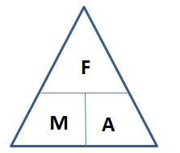

3rd Law of Motion – For every action there is an equal and opposite reaction.

7. What is the mass of an object that needs a force of 4,500 N to accelerate it at a rate of 5 m/s2.
F= ____________ m= _____________ a= __________
8. What is the acceleration of a 2,000 kilogram truck if a force of 4,200 N is used to make it start moving forward?
F= ____________ m= _____________ a= __________
9. A 10 kg bowling ball would require what force to accelerate down an alleyway at a rate of 3 m/s2?
F= ____________ m= _____________ a= __________
10. A massive linebacker collides with a smaller halfback at midfield. The force experienced by the linebacker is __________________ (less than, equal to, or greater than) the force experienced by the halfback. The resulting acceleration of the linebacker is _________________ (less than, equal to, or greater than) the resulting acceleration of the halfback.

11. You are waiting in line to use the diving board at your local pool. While watching people dive into the pool from the board, you realize that using a diving board to spring into the air before a dive is a good example of Newton’s third law of motion. Explain how a diving board illustrates Newton’s third law of motion.

12. In the diagrams below the action forces have been labeled with arrows. In each diagram label the reaction forces with arrows.

